In the Footsteps of Jesus

Pink Journey 3

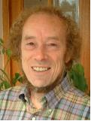

In this space the focus is on the life and work of Jesus. When we think about how we can respect the integrity of creation and sustain and renew the earth, we can turn to Jesus to see what inspiration and dedication to his word we can take with us in trying to find out what God is doing and how we can help. In what ways did Jesus both encounter and talk about the creation? Where was he and what was he doing? In this space you can spend time following in the footsteps of Jesus and thinking about how the Gospels offer us signposts for our own lives.

This space offers a number of passages for you to consider, with some questions for reflection as we try to follow in Jesus’ footsteps and imagine his own experiences.

The Lilies of the Field

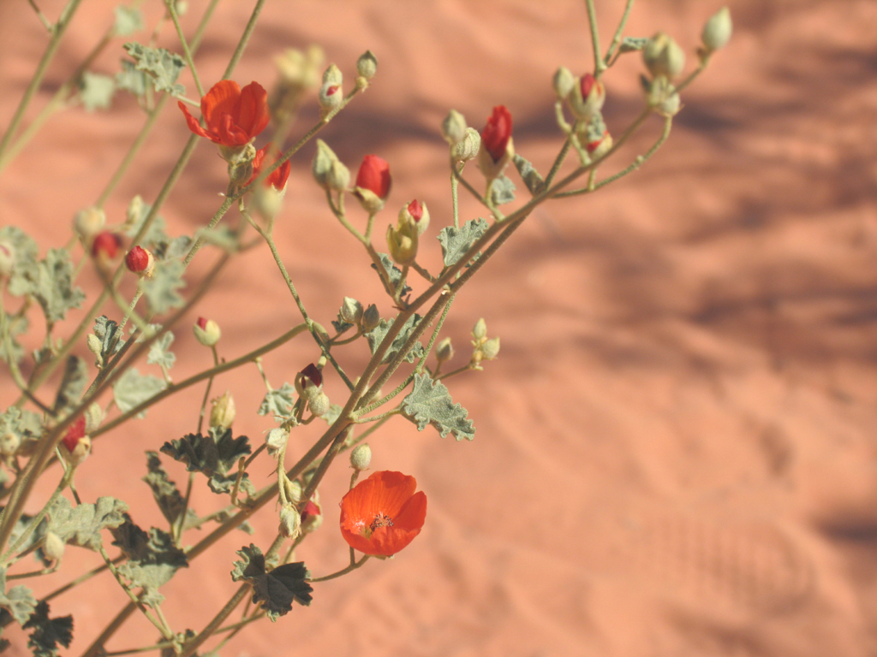

http://www.morguefile.com/archive/display/160560

Matthew 6. 25-34

"Therefore I tell you, do not worry about your life, what you will eat or drink; or about your body, what you will wear. Is not life more important than food, and the body more important than clothes? Look at the birds of the air; they do not sow or reap or store away in barns, and yet your heavenly Father feeds them. Are you not much more valuable than they? Who of you by worrying can add a single hour to his life?
"And why do you worry about clothes? See how the lilies of the field grow. They do not labour or spin. Yet I tell you that not even Solomon in all his splendour was dressed like one of these. If that is how God clothes the grass of the field, which is here today and tomorrow is thrown into the fire, will he not much more clothe you, O you of little faith? So do not worry, saying, 'What shall we eat?' or 'What shall we drink?' or 'What shall we wear?' For the pagans run after all these things, and your heavenly Father knows that you need them. But seek first his kingdom and his righteousness, and all these things will be given to you as well. Therefore do not worry about tomorrow, for tomorrow will worry about itself. Each day has enough trouble of its own.

- What do you think we learn about Jesus’ view of nature?
- Why do you think Jesus directs the disciples to think about God and the creation?
- What’s the point he is making?

The Storm



http://www.morguefile.com/archive/display/763658

Matthew 8.23-27

Then he got into the boat and his disciples followed him. Without warning, a furious storm came up on the lake, so that the waves swept over the boat. But Jesus was sleeping. The disciples went and woke him, saying, "Lord, save us! We're going to drown!"
He replied, "You of little faith, why are you so afraid?" Then he got up and rebuked the winds and the waves, and it was completely calm.
The men were amazed and asked, "What kind of man is this? Even the winds and the waves obey him!"
- What do you think we learn about Jesus’ relationship with the natural world?
- Why do you think the disciples are so afraid?
- What point does Jesus make to them?

The Fig Tree
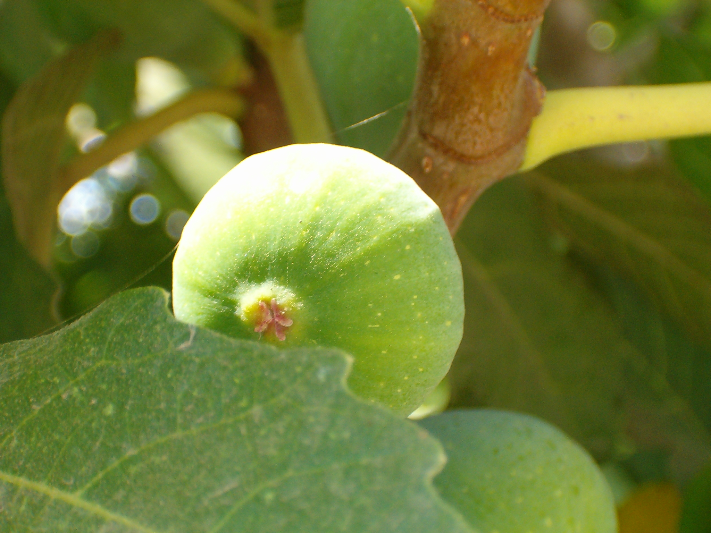
http://www.morguefile.com/archive/display/27937

Mark 11.12-14;20-21
On the following day, when they came from Bethany, he was hungry. Seeing in the distance a fig tree in leaf, he went to see whether perhaps he would find anything on it. When he came to it, he found nothing but leaves, for it was not the season for figs. He said to it, ‘May no one ever eat fruit from you again.’ And his disciples heard it….
In the morning as they passed by, they saw the fig tree withered away to its roots. Then Peter remembered and said to him, ‘Rabbi look! The fig tree that you cursed has withered’.

- What point is Jesus making?
- Why do you think the fig tree withered?
- How do you think the natural world helped Jesus explain God’s ways to his followers and friends?

It’s important to understand what Jesus tells us about the world we live in and what more we can do to know the will of the Father. Jesus talks about flowers, foxes, sparrows, trees, and about going as far as humanly possible to save a lost sheep. He was aware of his environment and reminds us that God makes provision for animals and birds and knows where every sparrow falls. If we seek to follow Jesus and do the Father’s will, then these words can inspire us.

Where would you like to go now? Where else will this journey take you?
Pink journey 1, 2, 4 spirituality based activities, following Jesus, changing our lives
Yellow journey 2, 3, 4 – text based exploration
Green journey 1, 2, 3, 4 more things to do, research, look at
Blue journey 1,2,3,4 scripture, prayers, music, reflection

