Mourning the Queen

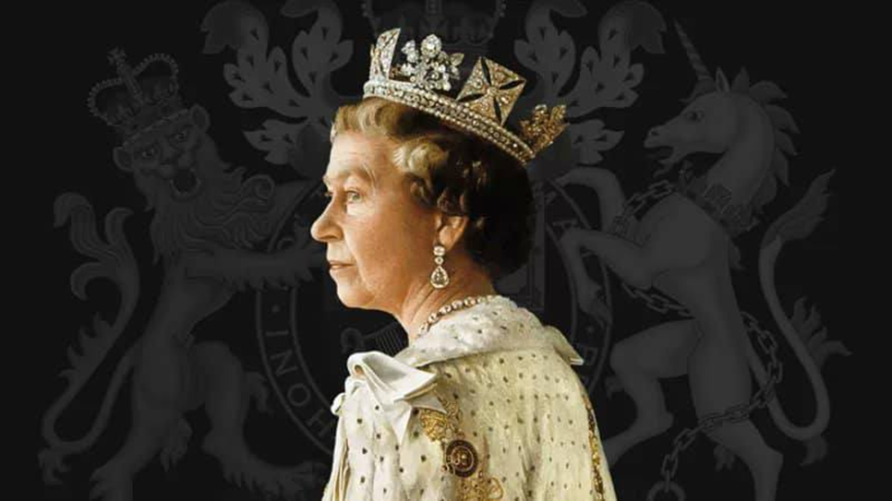

Many people are telling us that they have found themselves surprised by the strength of their emotions on hearing of her Majesty the Queen’s death and been affected by the extensive news coverage of the funeral arrangements. Even some of those who are not especially interested in, or enamoured of, the royal family, have been moved by the scenes surrounding the funeral procedures and wondered why they feel upset or even worried, and wonder what to do with such feelings.
One of the things we perhaps don’t realise, is how deeply ingrained the presence of the Queen has been in our national memory as we have grown up with a Sovereign on the throne. The Queen’s image is all around us in little things that we handle and use, like money, our stamps. Many people have told us about watching her televised appearance and message at Christmas and about her presence at national events and ceremonial occasions like the Queen’s Speech. Others have recalled the Queen’s appearances at the Cenotaph on Remembrance Sunday. Most people show they know something about the Queen and the Royal Family. For some people seeing or meeting the Queen at an event or in order to receive an award, becomes an important memory which they have wanted to share with us.
Some people are talking about what they read in the newspapers; others focus on the Queen’s love of horses and dogs; yet others remember pictures of the royal weddings and attendance at many church services. For some, her words about her Christian faith deeply resonate, especially perhaps in relation to her husband’s death when it prompts memories of our own losses and grief.
A time of national mourning, as crowds turn out to see the coffin, or come to London or just to local spaces, to lay flowers, cards, send messages or sign books of condolence, set off in us something often too deep for words. As with the death of Princess Diana, people feel a need to do something, say something or perform some pilgrimage or action to acknowledge that something momentous has happened and that something everyone took for granted has irrevocably changed. Many people have shared stories of feeling unsettled, destabilised, by the loss of the Queen. Others find this very particular death has awakened the pain of deaths in their own family and rekindles grief, especially after Covid. Yet others tell us they feel angry and confused – perhaps because they didn’t like the monarchy very much or find the events bewildering.
People coming to this site have asked us for some ideas of how to acknowledge the spiritual feelings of all this and here are some very simple ideas:
TALK to someone about what you are seeing, hearing and feeling. Talk to family, friends, neighbours, or find a local clergy person. If you don’t know any local churches or church ministers, we can help you find someone to have a chat with, share your memories with or cry with. Use our ASK page contact form if you want to do that.
DO something that feels like you have offered something of yourself or contributed to this historic time of mourning. You don’t have to go to London, lay flowers or send gifts cards if that is difficult or not something you want to do. You could light a candle, or just keep a short time of silence. Or find out where your local area is providing a book of condolence and sign it. https://www.royal.uk/send-message-condolence ; https://www.bbc.co.uk/news/uk-62847406
SAY A PRAYER, go along to a local church service where you will be very welcome, or just spend some time with a bible reading, hymn or spiritual reading or a poem which comforts you. If you want suggestions for that, use our ASK contact form and we can send you some ideas.
USE THIS TIME as a time of spiritual reflection. There are many memes now on the internet imagining the Queen being reunited with Prince Philip and her dogs and horses as well as different memes of sadness, thankfulness and gratitude. And quite a lot about Paddington Bear. But how do you think about death and the promises of Christian faith that death is not the end? At the same time, there is a focus on the new King and all his family and what the future will look like. What might you take from the Queen’s life and what are your hopes for the future of your life and the life of this country? How might your faith figure in that?

Some links to reaction and resources from Christian churches:
https://www.churchofengland.org/
https://www.cbcew.org.uk/
https://www.methodist.org.uk/
https://www.churchinwales.org.uk/en/
https://www.scotland.anglican.org/
https://www.ireland.anglican.org/
https://www.churchofscotland.org.uk/
https://urc.org.uk/urc-shares-nations-grief-on-the-death-of-queen/
https://www.congregational.org.uk/general-secretary/her-majesty-queen-elizabeth-ii
https://www.salvationarmy.org.uk/
https://www.presbyterianireland.org/

