14-20th April 2012
Groups
Godly Play for children
http://godlyplay.us4.list-manage1.com/subscribe?u=a8b7f96ec2e41f98b3454c099&id=45959e2389
http://www.facebook.com/groups/GodlyPlayUK/
Back to Church Sunday
http://www.facebook.com/backtochurchsunday

Recommended books
The Christian and the Pharisee by R T Kendall
Chasing Francis on St Francis of Assisi
http://www.amazon.com/Chasing-Francis-Pilgrims-Tale-TrueColors/dp/1576838129/ref=sr_1_7?ie=UTF8&qid=1334537183&sr=8-7

Newspaper articles
English Defence League tag of ‘creepingsharia’ ridiculed on Twitter
http://www.guardian.co.uk/commentisfree/2012/apr/16/twitter-users-turned-on-english-defence-league?newsfeed=true
Evangelical Christians are from another planet http://www.guardian.co.uk/commentisfree/andrewbrown/2012/apr/19/evangelical-christians-another-planet
Children with rickets in the UK http://www.bbc.co.uk/news/uk-england-london-17780954 r
Gay marriage and the Church http://thinkprogress.org/lgbt/2012/04/18/466389/archbishop-wales-marriage/?fb_comment_id=fbc_10150676347667607_22114066_10150685650552607&mobile=nc#f1e1b37248
http://www.independent.co.uk/news/uk/home-news/archbishop-of-wales-publicly-calls-on-anglicans-to-support-gay-civil-marriages-7657820.html
Anders Behring Breivik reflects changing face of modern far right
http://www.guardian.co.uk/world/2012/apr/18/anders-behring-breivik-modern-far-right?newsfeed=true

Living Biblically
http://www.guardian.co.uk/lifeandstyle/the-womens-blog-with-jane-martinson/2011/oct/06/woman-year-living-biblically

Conferences and events
Reaching Out in Mind Body & Spirit conference http://www.churcharmy.org.uk/ms/sc/Evangelism/sfc_ROMBS.aspx
Imagine workshop for the London Institute of Contemporary Christianity
http://www.licc.org.uk/shop/product/imagine-on-the-road-winchester-25-apr-2012
Interesting blogs and blog posts
Asbo Jesus http://asbojesus.wordpress.com/2012/04/19/1080-10-years-of-jonny/
Jonny Baker http://jonnybaker.blogs.com/jonnybaker/2012/04/the-pilgrims-way.html
Bishop Alan Wilson http://networkedblogs.com/wBWMF on gay marriage
Elizaphanian: http://elizaphanian.blogspot.co.uk/2012/04/efficiency-and-resilience-in-church-of.html

Campaigns
Children Society: Fair and Square campaign
http://action.childrenssociety.org.uk/page/signup/fair-and-square-free-school-meals-campaign?utm_medium=facebook&utm_source=childsoc&utm_campaign=20120418fslaunch&source=20120418fslaunch

Youtube clips
Missa at Wakefield cathedral http://www.youtube.com/watch?v=cJBt1Q5nEPg

Spiritual Thoughts
Bishop Paul Bayes
Merton: The way to find the real "world" is not merely to measure and observe what is outside us, but to discover our own inner ground
No distrust made him waver concerning the promise of God... being fully convinced that God was able to do what he had promised. #lectionary

Miscellaneous
New Testament Diamond Jubilee Edition
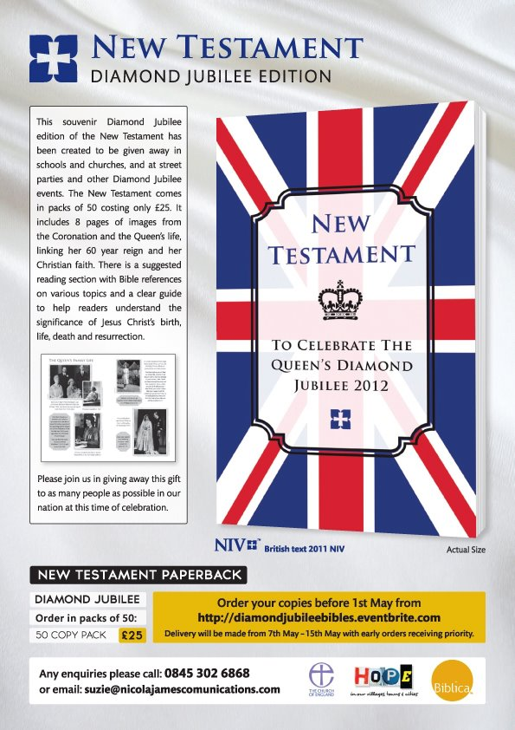
http://www.churchofengland.org/media-centre/news/2012/04/diamond-jubilee-new-testament-published.aspx

