Facebook stuff from May 20th 2013
Mission:
Back to Church Sunday Packs are available tomorrow! Watch this space! #invitationalchurch
http://www.freshexpressions.org.uk/stories/arkcrawcrook?utm_content=buffera4061&utm_source=buffer&utm_medium=twitter&utm_campaign=Buffer
http://www.theworkofthepeople.com/the-cosmic-christ
Stuff from bishops:
Bishop Brian Castle talks about memory, music, laughing and crying in 'pubs, churches and community' http://www.briancastle.org/content/pubs-churches-and-community
From Bishop Paul Bayes
"...they gazed on God; they ate and they drank" (Exodus 24:11) #corpuschristi as #feedingmiracle http://t.co/CrI6JPKlGT
#dailyprayer Faithful God, let yr word be the treasure of our hrts, that we may delight in yr truth & walk in the glorious liberty of yr Son
#dailyprayer hope does not disappoint us, because God’s love has been poured into our hearts through the Holy Spirit that has been given us
From Bishop Alan Wilson – restorative justice in action
http://www.guardian.co.uk/uk/2013/may/28/iphone-thief-mobile-phone-snatched

Books
New book from Paula Gooder
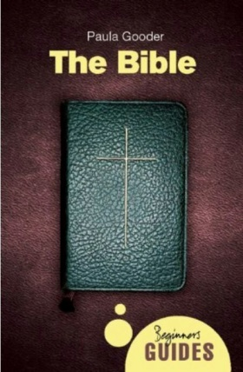
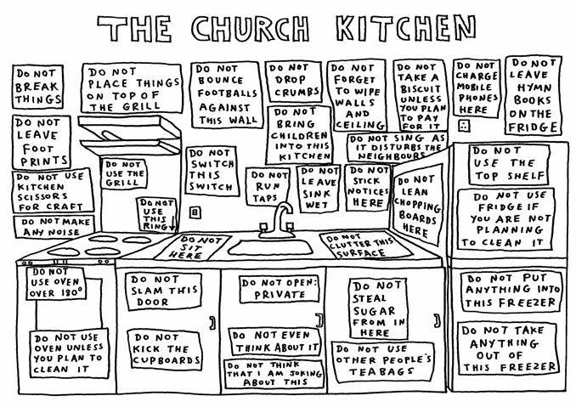
Events
Event 8th June with Steve Hollinghurst
www.engagingevent.info
From Juliet Kilpin:

