Sense Making Faith p 57

Exploring a herb garden

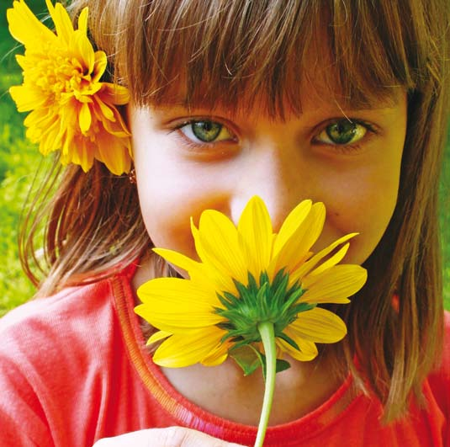

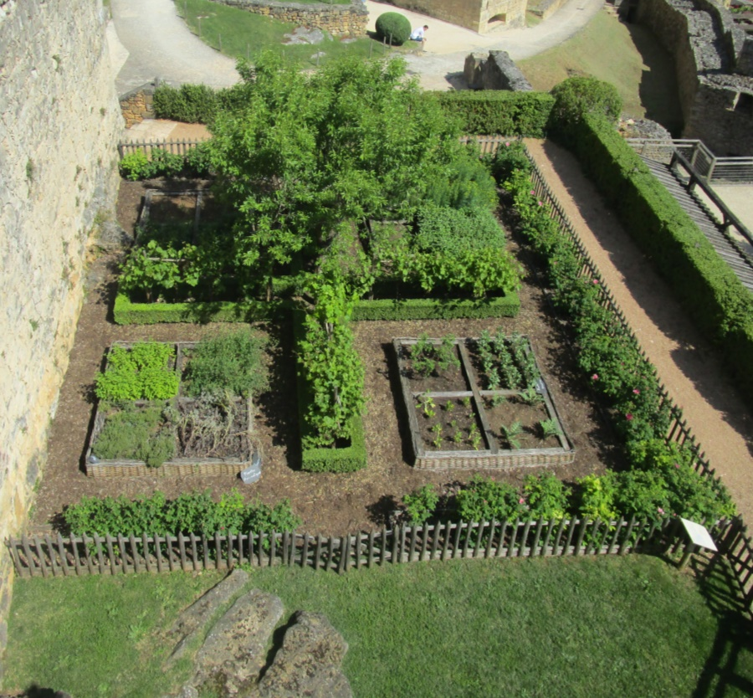
Photo: Anne Richards

In the past many religious communities kept a herb garden. Monks and nuns not only contemplated the relationship between God, human beings and the natural world, but were concerned for the pastoral and spiritual care of people often living in troubled times. Before the advent of modern medicine, help for illness, anxiety or other troubles came from combining prayer, pastoral care and whatever remedies might be available. People would come to religious communities in their area for all kinds of help, -food, alms, medicine, personal and spiritual problems. So plants were kept for medicinal purposes, to make infusions, to sweeten the air in a world which often smelled very bad, to add to food and to remind people of God’s bounty. The use of herbs has a long history and they are found throughout scripture. Psalm 51 says ‘wash me with hyssop and I shall be clean’. Bitter herbs were (and are) part of the Passover meal, and thus part of Jesus’ Last Supper.

Ancient herbalists cultivated herbs in particular categories. These were:
- Household Plants, which could be dried for decoration or kept indoors such as Teasels.
- Medicinal plants, such as Comfrey, and Feverfew
- Aromatic Plants, such as Lavender, and Lemon Balm
- Kitchen and Seasoning Plants, such as Basil which were used in cooking
- Plants for artwork such as Agrimony
The kind of herbs which were grown and cultivated are still around today. Here are some examples:
Agrimony (Agrimonia eupatoria) was used to make an infusion which would cheer the drinker. It was also used to make a yellow dye.
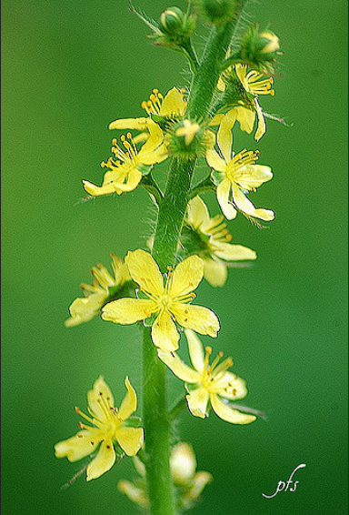
Photo: Paul Stevens
Alchemilla (Alchemilla vulgaris) is also known as Ladies Mantle. It was believed that this had medicinal properties which would help women with problems deriving from menstruation to menopause (as was Mugwort). Along with Betony(Stachys Officinalis), it was also thought to help headaches. Inhaling the smoke of burning Betony was also thought to ease congested lungs. Another herb used for a bad chest was White Horehound (Marrubium vulgare)
Photo: Manuel M V
Anise (Pimpenella anisum). The seeds are liquorice-scented, so these were often offered to people to sweeten bad breath as in former times people so often had rotten teeth. It was used as a flavouring and to help digestion.
Photo: Caligula1995
Basil and Bay (Laurus nobilis) are both used in cooking. Bay is an evergreen which has leaves that dry quickly and easily. They were stored to provide flavour in soups, stews and fish dishes. Basil is a sweet smelling perennial often used in cooking.
Photo: Isaac Wedin
Borage (Borago officinalis) is a blue flower with light coloured prickly hairy leaves. Apart from being an attractive plant in its own right, it was thought to cheer up people who were depressed or sad. One tradition it was added to a farewell drink for those leaving to fight in the crusades as it would give courage.
Photo: Matthew Dillon
Caraway (Carum carvi) is also an aromatic plant. The seeds were used to flavour sweets and drinks, as were the seeds of Lovage. Caraway was also sometimes used by people to keep away thieves as the scent would get on thieves’’ hands and give them away.
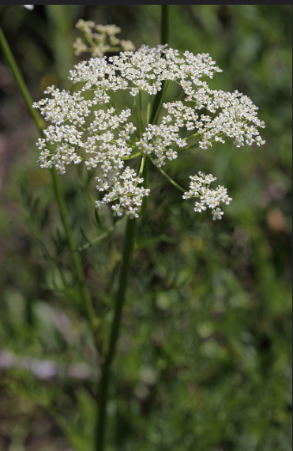
Photo: Andrey Zharkikh
Chamomile (Chamaemelum nobile) was added to water used for washing as it gave a sweet smell. It was infused as a way of soothing a headache or calm a person down. It was also used as a carpeting plant because it was supposed to give paths a sweet smell when walked on.
Photo: Steve Slater
Lavender (Lavandula angustifolia) is still best known as a sweet scented flower which can be dried and used to scent clothes and water. Lavender oil was used to treat headaches and worry as well as a personal fragrance and to keep insects away at night.
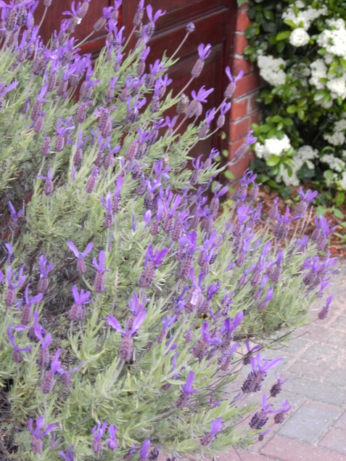
Photo: Anne Richards
Lemon Balm or Melissa (Melissa officinalis) is a lemon scented plant used to make a drink for people with colds.
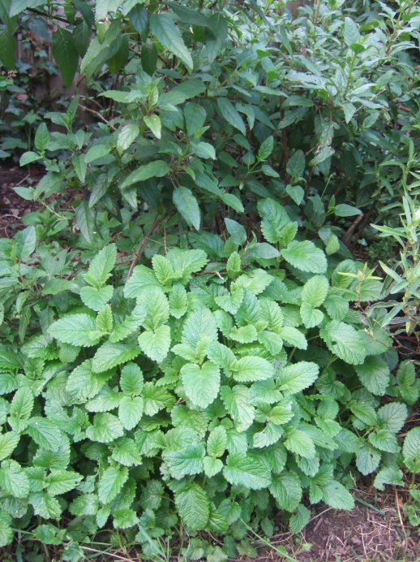
Photo: Anne Richards
Mint (Mentha) of all kinds was used in both food and medicine. Mint vinegar was used as a mouthwash and it was supposed to be especially good for the stomach.
Photo: Mark Chinnick
Rosemary (Rosmarinus officinalis) was used in washing water, an infusion for colds and to disguise the flavour of poor meat. It was placed in churches a shrub-like tender perennial with spiky pine-scented leaves and is symbolic sometimes because it was understood to be symbolic of both wisdom and faithfulness and the memory of Jesus.
Photo: Peter Madsen
Rue (Ruta graveolens) was called by the monks the Herb of Repentance. It was also called the ‘herb of grace' because it was used as a holy water sprinkler. It was put on bites and on the eyes.
Photo: Kurt Stuber
Sage (Salvia officinalis) also had symbolic usage as age and wisdom. It was thought to make people feel happier and used to treat stomach complaints.
Photo: Rebecca Siegel
Selfheal (Prunella vulgaris) was put on wounds as it was supposed to help with clotting as was Bruisewort.
Photo: ianpreston
Thyme (Thymus vulgaris) was used to flavour cooking juices and was also used in bath water or could be burned to protect against infection.
Photo: Rae Allen
Yarrow (Achillea millefolium) was a medieval cure-all for headaches, colds and wounds, especially battle wounds, and the bite of mad dogs. It was also recommended for fatigue, cystitis, incontinence and dysentery.
Photo: Patrick Standish
You can explore a virtual herb garden at:
http://www.newyorkcarver.com/Abbeygarden.htm

