Praying when you have never prayed before

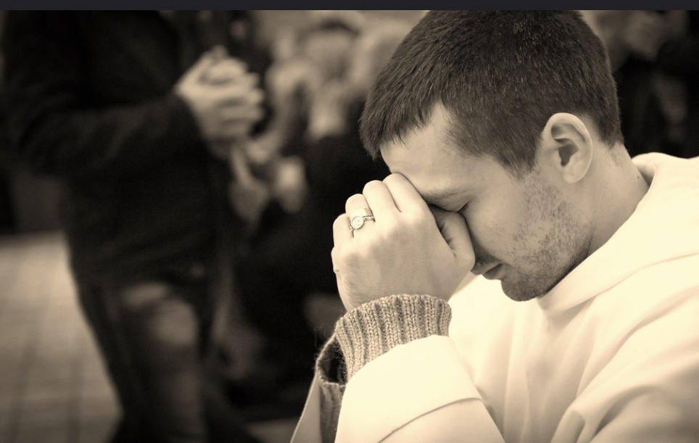
Ninac26/flickr

What is prayer?
Praying is a natural human instinct. Despite what you might think, you do not have to believe in God, belong to a faith or have a specific spirituality to pray.
Prayer is sometimes described as a reaching out to something or someone beyond your own self (such as God) or a feeling for something divine found deep within your own self.
As an individual, you can pray using words, forming thoughts, imagining pictures or looking inwards towards nothingness and silence. There is no right way to pray and everyone’s way of praying is different.
You don’t have to be especially respectful or try to be holy when you pray. You can pray through whatever emotions or feelings you have. It is ok to be angry, joyful or filled with grief.
You can pray by yourself or with others. You don’t have to close your eyes, lower your head and fold your hands, but some people find this helps shut out distractions and compose themselves for prayer.
If you want to pray in words, you can say or think any words you like. There are lots of good printed prayers available, but your own words or thoughts are just as good.
If you want to pray in pictures, just visualise what it is you want to make the basis of your prayer. It might be a person, a situation or just a feeling made into a picture or just a jumble of bits and pieces.
If you want to focus on clearing your mind and waiting, just pull away from any distractions around you. You can focus on your breathing and body rhythms to help with this. There are lots of different kinds of meditations and focussing exercises available to help you do this.
No prayer has to be polished and perfect to be effective, or even have a particular beginning or end.

Prayer actions

Michael Kondouris/flickr
Some people like to light a candle as a focus for prayer. If you are at home and it isn’t safe to light a candle, an electric candle or switching on a lamp or a torch in a dark room can be just as helpful. There are also places to ‘light a candle’ online
https://gratefulness.org/light-a-candle/ https://www.churchofengland.org/life-events/funerals/light-candle-remember-someone https://www.lightingacandle.org/chapels/st-jude
Some people use beads (a rosary or prayer beads) in different faith traditions to help them concentrate on praying. There are set prayers for the rosary but you can use the beads as an aid to whatever you want to think or say. Hold each bead in turn as you pray until you have gone round the circle. Sometimes people hold a small cross or pebble to help them focus and shut out distractions.
Some people have other creative ways to pray, such as writing down or drawing what they want to pray, and then disposing of the paper after praying. Some people draw a circle in stages as they work through what they want to pray about and join the circle to complete the process. Other people pick up and place objects as a focus for prayers. Yet others pray ‘over’ their daily routines and activities, or over photographs or newspaper articles.
You can also sing, dance or chant prayers or use singing or chanting to create a prayerful state.

Finding ‘hooks’ for prayer throughout the day
Some people who pray regularly do so at particular times during the day. If you are not used to praying or finding it difficult, you might find it helpful to start while you are doing something else that is a regular activity. For example, being at home now you might be more conscious of regular activities, maybe at more fixed times than usually. Things like making coffee or meals, waiting for a kettle to boil, brushing your teeth, washing your hands, feeding the dog/cat, feeding a baby, putting children to bed, opening your computer, changing your passwords. All of these things can become ‘hooks’ for something you want to ‘offer up’.
Or you can focus in the pauses that happen when the post arrives or while in a queue waiting to enter the supermarket. Those pauses might let you bring to mind the needs of others like shop workers or the post delivery person and praying like this can help you feel more hopeful and thankful. Counting your blessings in those pauses can help too.
We have also written a simple prayer and blessing for the time of the Coronavirus epidemic which you can use if you like on any occasion. See it here: http://www.spiritualjourneys.org.uk/do/PrayerandBlessingduringtheCoronavirusepidemicscreen.pdf.pdf

Memories and rhythms
You might like to find things in your home that have particular memories or associations with people, reflecting and being thankful (or angry) about those memories. If you go out for your exercise, the walk can begin to become a walk with God, the rhythm of walking, jogging or cycling can fit in with a short prayerful sentence of a few words.

Types of prayer
Why do you want to pray? Here are some of the reasons people feel they need to pray.
Asking for help
Asking for help for others
Asking for forgiveness
Being thankful and glad
Feeling awe and wonder

Believing in God

You don’t have to believe in God to pray, but most people have a sense of an Other to whom they are connected, when they pray. But atheists will also pray sometimes, even if they don’t think there is a God to receive their prayers. https://www.theguardian.com/world/2018/jan/14/half-of-non-believers-pray-says-poll

Does God answer prayer?

Many people say that their prayers have been answered, which is why praying in gratitude is also important, but sometimes it takes time to see what the ‘answer’ really was. It may not happen the way you would like or expect. The world may not change because of your prayer and what you are asking for may not simply happen. But prayer is a powerful tool for spiritual growth and human connection. People often feel a lot better and do better if they have been prayed with, or for. Praying also helps us deal with our anxieties and emotions and creates a space for us to change what we can, and often to find hope in the darkest times. Praying can help us understand more about God and about our own spiritual searches and journeys. Prayer can help us with overwhelming situations, like the birth of a baby or the illness or death of a loved one. Prayer can help with anxious, or stressful situations; it can help anchor feelings of joy and expectation or open or close experiences or just the life of your day.

Christian prayer – The ‘Lord’s Prayer’

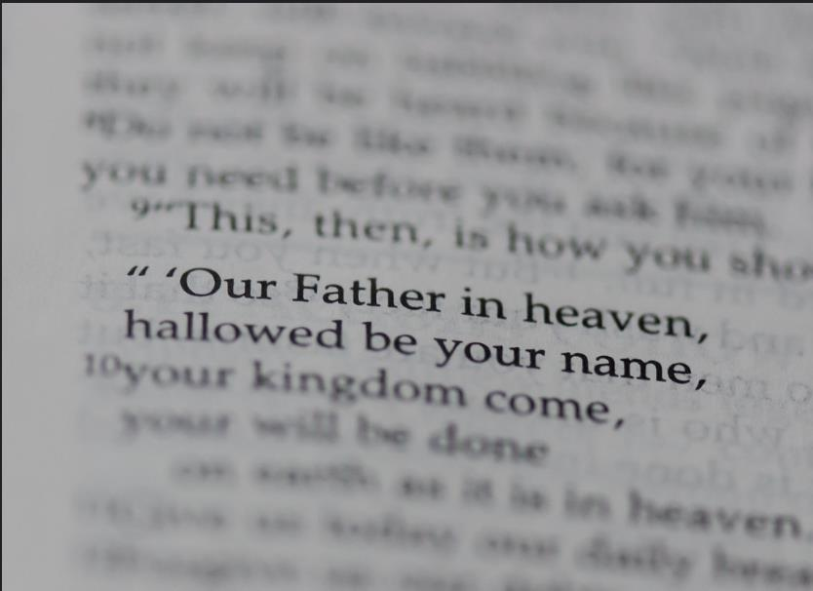
Bradhoc/flickr

The Bible says that Jesus was asked what is the best way to pray (New Testament, Gospel of Matthew, chapter 6, verses 9-13). The reply he gave is ‘The Lord’s Prayer’ -which means the prayer that Jesus (the Lord) gave to his followers. The modern version goes:
Our Father in heaven,
Hallowed (holy) be your name
Your Kingdom come
Your will be done on earth as in heaven.
Give us this day our daily bread
And forgive us our sins
As we forgive those who sin against us.
Lead us not into temptation
But deliver us from evil.
Amen

What is this prayer about?
In this prayer, the first section creates a frame for us to think about and relate to God. Jesus suggests that people can think about God as a loving parent, not some distant power at whom we have to shout. He goes on to suggest that we should think of God as holy, the source of all that is good and acknowledge that. The next part of the prayer asks for God’s loving purpose to happen all around us (the kingdom). Opening our prayer like this helps us think of the divine love, goodness and purpose in which we are involved, not left out.
In the next part of the prayer, Jesus suggests we ask for what we need – our physical needs, our food, and our spiritual needs, -forgiveness and reconciliation with others.
Then we ask God to help us stay away from things that take us away from love, goodness and purpose and to keep us safe.
When we say ‘Amen’ at the end of the prayer it is to affirm all we have offered in the prayer. It means ‘So be it’.
Saying the Lord’s Prayer can be a good way to start praying and then adding whatever you particularly want to pray for or about.
Another prayer, called The Jesus Prayer, is often used by Christians to connect to God in a simple, calming, repetitive way : ‘Lord Jesus Christ, Son of God, have mercy on me, a sinner’. It is a way of asking for help from God who is alongside us, recognising that we need help. ‘Sin’ means to fall short of what God wants for us.
https://www.churchofengland.org/our-faith/going-church/lords-prayer See the traditional version of the Lord’s Prayer here too.
https://www.bbc.co.uk/religion/religions/christianity/prayer/lordsprayer_1.shtml A beautiful conversation with Rowan Williams, former Archbishop of Canterbury about the inner meanings of the Lord’s Prayer.

