November Season

Reconciling Mission through Prayer and Reflection

5. Christ the King: Endings and Beginnings

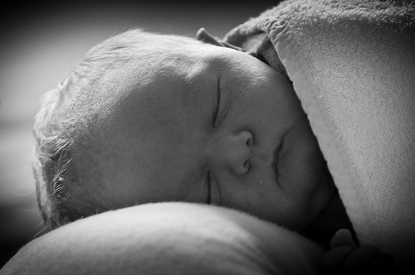

Photo: Jan de Graaf

Reflection

Saul, by Rosemary Kay, is the story of a baby born prematurely at 23 weeks. He survives against all odds and in the face of terrible struggle until, just before his term date, he gets meningitis and dies. This true story is fictionalised by his mother so that it is told in the first person, which gives his short life meaning and purpose, but also does more. Saul’s life is the story of each one of us from birth to death. He was meant to be born perfect, but he wasn’t. He wasn’t born in the fullness of time, but prematurely, before the Good Time. He has a memory of perfection, but his struggles take him further and further away from it. Yet through it all he knows there is a good story to live by. He is guided by the knowledge of a greater and more wonderful reality, which he experiences after his death. As we journey with him in the face of his terrible suffering we discover with him that his life, which is full of pain and misfortune, is transfigured by love.

Food for thought, or for group discussion
What happens when the future turns out to be very different from the one you anticipated? Where do you find meaning and new hope?

Towards the end of his life, Saul learns to hate the nurses, doctors and endless procedures which cause him pain. In order to protect himself in his helplessness and vulnerability, he becomes remote, hard and filled with hatred. But he can’t stay that way:

‘We all laughed and the laughing made something go crack! Inside me. It was the hard feelings starting to crack open....And soon, I couldn’t stop myself from dancing....I couldn’t stay stiff and angry. How could I?...

...There was no more hate. Instead I started to glow. The mean, hard feelings melted and left a great shaft of happiness, all fresh and clean.’ p. 270-272; 282.

Saul’s story reminds us that there has to be a time when hating turns to dancing. The time of reconciliation is when the energy that has to be put into hating is used instead for love and joy. Reconciliation in this life is when the hating turns to dancing.

This is echoed in words from St Anselm on the conception of Jesus:

Blessed Lady, sky and stars, earth and rivers, day and night – everything that is subject to the power or use of man – rejoice that through you they are in some sense restored to their lost beauty and are endowed with inexpressible new grace. All creatures were dead, as it were, useless for men or for the praise of God, who made them. The world, contrary to its true destiny, was corrupted and tainted by the acts of men who served idols. Now all creation has been restored to life and rejoices that it is controlled and given splendour by men who believe in God. The universe rejoices with new and indefinable loveliness. Not only does it feel the unseen presence of God himself, its Creator, it sees him openly, working and making it holy. These great blessings spring from the blessed fruit of Mary’s womb. Through the fullness of the grace that was given you, dead things rejoice in their freedom, and those in heaven are glad to be made new. Through the Son who was the glorious fruit of your virgin womb, just souls who died before his life-giving death rejoice as they are freed from captivity, and the angels are glad at the restoration of their shattered domain. Lady, full and overflowing with grace, all creation receives new life from your abundance.

Food for thought or for group discussion
The run up to Christmas is a time of tension and difficulty for many families. What can we do to help people make their Christmas a time of dancing, not hating?

Exploring Scripture

2. Cor 5. 16-21
16 So from now on we regard no one from a worldly point of view. Though we once regarded Christ in this way, we do so no longer. 17 Therefore, if anyone is in Christ, the new creation has come: the old has gone, the new is here! 18 All this is from God, who reconciled us to himself through Christ and gave us the ministry of reconciliation: 19 that God was reconciling the world to himself in Christ, not counting people’s sins against them. And he has committed to us the message of reconciliation. 20 We are therefore Christ’s ambassadors, as though God were making his appeal through us. We implore you on Christ’s behalf: be reconciled to God. 21 God made him who had no sin to be sin for us, so that in him we might become the righteousness of God.

Food for thought, or for group discussion
Where, in this time of preparation, will you be the ambassadors of Christ the King? Where will you hope to see a ‘new creation’?

Prayer

Lord,
Each life is a departure
A train leaving a station
A journey from your door
Help us to know our destination
Our place of final alighting
And to make the most of the journey
Using whatever we have to take with us
To make sense of where we have to go
The place where you await us

Lord,
Deliver us from apathy,
Blankness, detachment,
A turning away.
Help us to help those
Who have fallen into despair
Whose lives are full of leavings
Endings but no beginnings.

Lord
Help us to see the vision
Of your face in each face
We meet on every street
Use us, our hands and eyes and lips
To lift others towards your prefected face
For you to gathering them in
To the time of dancing
You are the potter, Lord
We are the clay,
Remake us.

Amen

